Brain Anatomy Terms
Peripheral Nervous System –
Autonomic –
Sympathetic -
Parasympathetic -
Somatic –
Central Nervous System –
Brain Scans
EEG (Electroencephalogram) –
CT (Computed Tomography) –
PET (Positron Emission Tomography) –
MRI (Magnetic Resonance Imaging) –
fMRI (functional MRI^) –
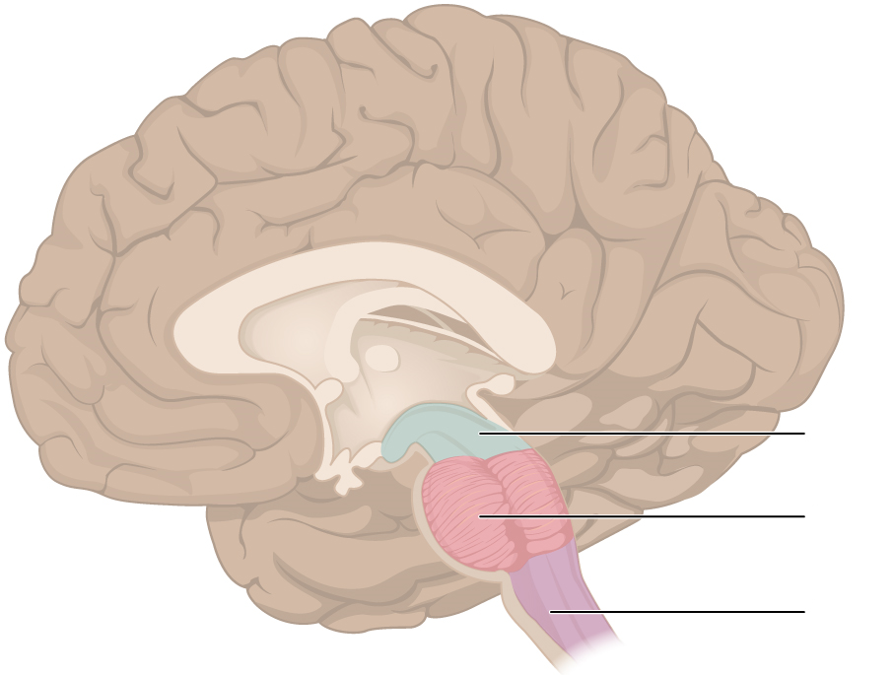
Brainstem
Brainstem –
Medulla –
reticular formation –
thalamus –
pons – Middle of BS –
cerebellum –
cerebrum –
Limbic System
Amygdala –
Hypothalamus –
Hippocampus –
Pitutary gland –
YOUR BRAIN
cerebral cortex –
glial cells –
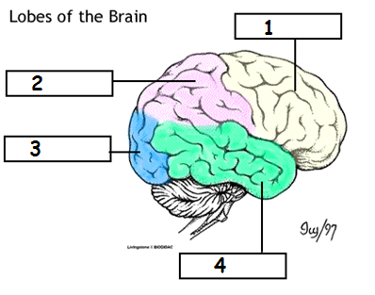
frontal lobe –
parietal lobe –
occipital lobe –
temporal lobe –
motor cortex –
sensory cortex –
association areas –
Broca’s area –
Wernicke’s area –
Corpus Callosum –
Plasticity –
Neurogenesis –
Problems
Leision –
Aphasia –
Theories
Split brain experiment
Identical Twins –
Fraternal Twins –
Nature/Nurture –

