Abnormal Psychology
What is “abnormal”
*
*
Benefits:
*
*
Problems
*
*
DSM-V
Axis I – “Clinical Syndrome” – (what disorder do they have?, e.g. Schizophenia or Anorexia)
Axis II – “Personality Disorder or Mental Retardation” (60 IQ, Antisocial Personality Disorder)
Axis III – “General Medical Condition” (Diabetes, Arthritis)
Axis IV – Psychosocial or Environmental Stressors (Homeless, Joint custody with parents)
Axis V – Global Assessment of Functioning (GAF) – Level of functioning on scale of 100

Categories
Anxiety Disorders
Somatoform Disorders
Dissociative Disorders
Mood
Schizophrenia
Personality``
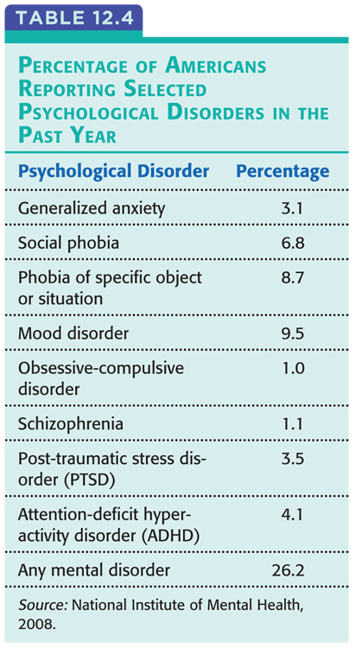
Rate of Disorders

