Motivation (8A)
Motivation
Instinct
Drive-Reduction Theory
Homeostasis
Incentive
Hierarchy of Needs
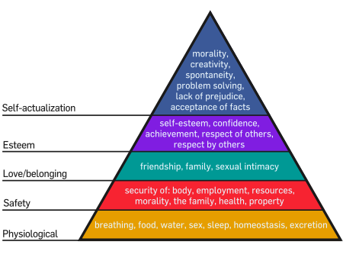
Glucose
Set Point
Estrogens
Testosterone
Sexual Orientation
Emotion (8B)
Emotion
James-Lange Theory
Cannon-Bard Theory
Two-Factor Theory
Polygraph
Facial Feedback
Catharsis
Feel-Good Do-Good Phenomenon
Well-Being
Adaptation-Level Phenomenon

