Motivation (8A)
Motivation – A need or desire that energizes and directs behavior
Instinct – Complex behavior that is rigidly patterned throughout a species and is unlearned
Drive-Reduction Theory – The idea that a physiological need creates an aroused tension state (a drive) that motivates an organism to satisfy the need
Homeostasis – A tendency to maintain a balanced or constant internal state; the regulation of any aspect of body chemistry such as blood glucose around a particular level.
Incentive – A positive or negative environmental stimulus that motivates behavior.
Hierarchy of Needs - Maslow
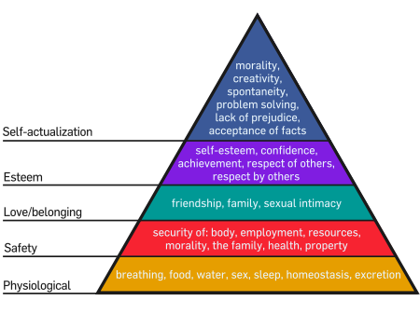
Glucose – the form of sugar that circulates in the blood and provides major source of energy for body tissues. When its level is low, we feel hunger.
Set Point – The point at which an individual’s “weight thermostat” is supposedly set. When the body falls below this weight, an increase in hunger and a lowered metabolic rate may act to restore the lost weight.
Estrogens – Female sex hormone
Testosterone – Male sex hormone
Sexual Orientation
Emotion (8B)
Emotion
- Physiological Arousal (Heart Pounding)
- Expressive Behaviors (Quickened Pace)
- Conscious thoughts and feelings (is this a kidnapping? – fear/joy)
James-Lange Theory
First physiological then “emotion”
Cannon-Bard Theory
Physiological and “emotion” (e.g. fear) happen at the same time
Two-Factor Theory
Arousal + “what is it?” = emotion
(p 368)
Polygraph
(show picture)
Arousal and Performance
Easy vs Difficult tasks – optimal arousal ---- Easy optimal high – difficult optimal low
Facial Feedback
Catharsis
Emotional Release
Feel-Good Do-Good Phenomenon
Tendency to be helpful when in a good mood
Well-Being
Self-Perceived happiness in life
Adaptation-Level Phenomenon
Our tendency to make judgments relative to prior experience

