Unit 10 Terms
Iceberg
Conscious
Preconscious
Unconscious
Id
Ego
Superego
Psychosexual Stages
Oral (<18mo)
Anal (18-36 mo) ~~ Anal “Retentive” or “Expulsive”
Phallic (3-6 years)
Latent (6-puberty)
Genital (puberty on)
Defense Mechanisms
Repression
Regression
Reaction Formation
Projection
Rationalization
Displacement
Sublimation
Denial
Importance of Childhood
Collective Unconscious
Psychoanalytic Theory Post-Freud
Projective Tests
Thematic Apperception Test
Rorschach Inkblot Test
Free Association
Oedipus Complex
Electra Complex
Neofreudian
Jung – Collective Unconscious
Horney – Feminist Rejection / Helplessness
Adler – Inferiority Complex
Carl Rogers
Criticism of psychoanalytic psychology
Humanistic Psychology
Abraham Maslow
Self-Actualization
Unconditional Positive Regard
Self-Concept
Humanistic psychology criticism
- Subjective
- Individualism
- Naïve
Traits
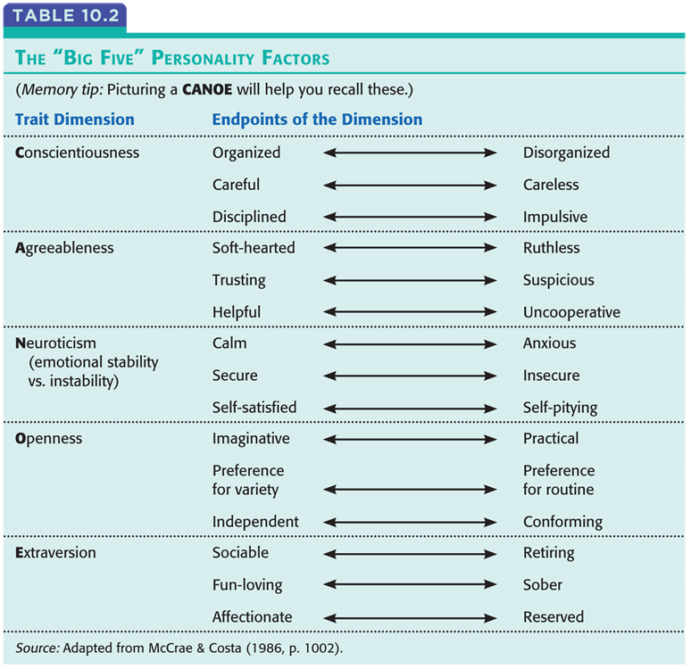
Factor Analysis
Personality Inventory
Minnesota Multiphasic Personality Inventory
(MMPI)
“The Big Five” (CANOE)

Social-Cognitive Perspective
Reciprocal Determinism
1. Different people choose different environments
2. Personalities shape how we react to events
3. Personalities create the situations to which we react
Locus of Control (Internal vs. External)
Self
Possible Self
Spotlight Effect
Self-Esteem
Self-Serving Bias (Lake Wobegon Effect)
Individualism vs Collectivism

